**Basic Dropdown**

A dropdown menu is a toggleable menu that allows the user to choose one value from a predefined list:

**Example :**

<div class="container mt-3">

<h2>Dropdowns</h2>

<p>The .dropdown class is used to indicate a dropdown menu.</p>

<p>Use the .dropdown-menu class to actually build the dropdown menu.</p>

<p>To open the dropdown menu, use a button or a link with a class of .dropdown-toggle and data-toggle="dropdown".</p>

<div class="dropdown">

<button type="button" class="btn btn-primary dropdown-toggle" data-bs-toggle="dropdown">

Dropdown button

</button>

<ul class="dropdown-menu">

<li><a class="dropdown-item" href="#">Link 1</a></li>

<li><a class="dropdown-item" href="#">Link 2</a></li>

<li><a class="dropdown-item" href="#">Link 3</a></li>

</ul>

</div>

</div>

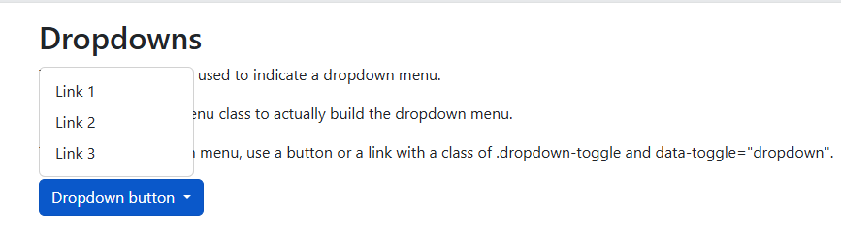

**Example Explained**

The .dropdown class indicates a dropdown menu.

To open the dropdown menu, use a button or a link with a class of .dropdown-toggle and the data-bs-toggle="dropdown" attribute.

Add the .dropdown-menu class to a container element, like <div> or <ul>, to actually build the dropdown menu. Then add the .dropdown-item class to each element (links or buttons) inside the dropdown menu.